**Pourna Sengupta**

**Matthew Kim**

**CSCI 3002-106**

**February 14, 2021**

**Data Set:** World Happiness Report 2019 (<https://www.kaggle.com/PromptCloudHQ/world-happiness-report-2019>)

**User Questions:**

* Do the people of more corrupt countries have more or less freedom?
* Which is the happiest country?
* Do countries with a higher GDP have healthier citizens? Are these countries happier?
* Which country’s citizens have the most freedom?

***Note:*** Matthew and I briefly met during recitation, during which I gave him my contact information since he had an exam during that time. He hasn’t contacted/communicated with me (I have waited to submit until 10:30 pm in case he did) and therefore, the feedback I received is from a friend instead. I hope this is alright, but if not, please let me know if there’s something else I should do to make sure I receive these points.

**Ladder vs. GDP vs. Health**

*Do countries with a higher GDP have healthier citizens? Are these countries happier?*

*Necessary Data: Country, Ladder Ranking, Log of GDP Ranking, Healthy Life Ranking*

*Note: Qatar, Somalia, and Syria do not have a GDP ranking in the data set.*

***A scatterplot shows the linear correlation between the datapoints and the varying wealth, happiness, and health between countries, therefore being the chose representation for this data comparison.***

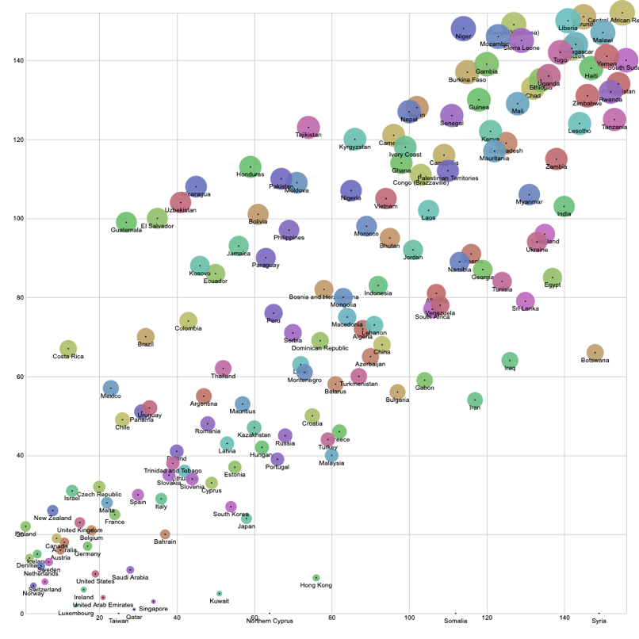***Figure 1:*** Ladder vs. GDP

The figure to the left shows a comparison of a country’s ladder ranking to its GDP ranking. There’s a direct linear correlation between countries higher on the ladder and their wealth. Wealthier countries are clearly happier than countries ranking in the lower 75% of the ladder.

The circles at each point represent each country’s GDP ranking. Smaller circles show a wealthier country with a higher GDP ranking.

A scatterplot shows the linear correlation between the datapoints and the varying wealth between countries, therefore being the chose representation for this data comparison.

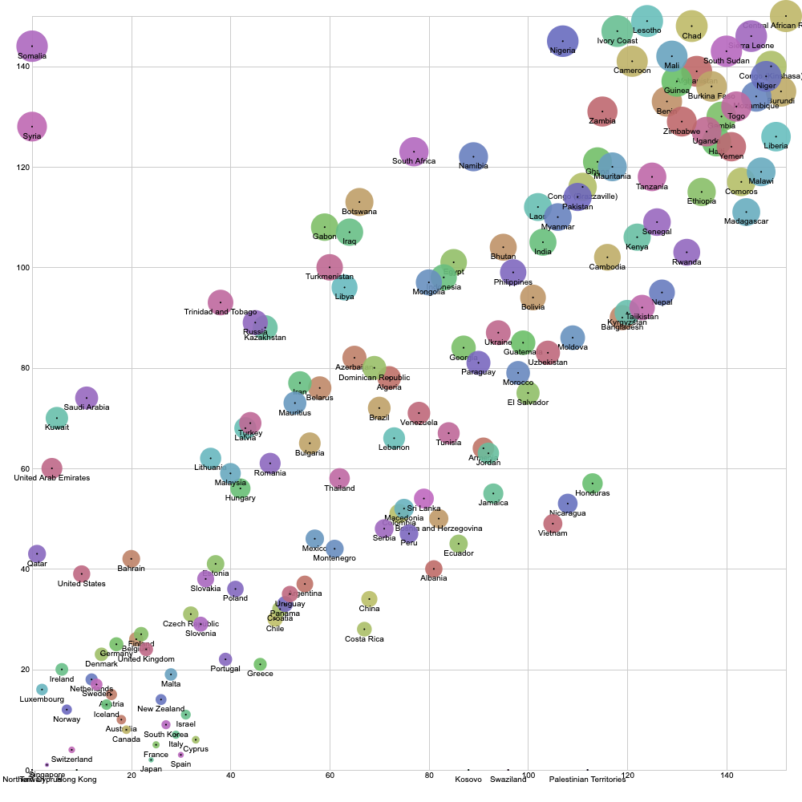

***Figure 2:*** GDP vs. Health

The data visualization to the right compares GDP ranking to Health ranking for each country. This visualization also shows a direct linear correlation between wealth and health. Wealthier countries have much healthier citizens. Similar to the above visualization (*Figure 1*), countries in the top 25% of GDP also lie in the top 25% of Health.

The circles in this visualization represent the Health ranking of a country, where those with healthier citizens have smaller circles.

**Feedback:** *Chris Sepp*

The two representations show the relationship between the data well and together, answer the question. The first scatter plot shows that happier countries have higher GDPs and the second shows that wealthier countries are healthier. The plots indicate that countries with better health are happier.

**Ladder vs. Freedom**

*Which country’s citizens have the most freedom?*

*Necessary Data: Country, Ladder Ranking, Freedom Ranking*

*Note: Qatar does not have a Freedom ranking in the data set.*

***A scatterplot shows the linear correlation between the datapoints and the varying wealth, happiness, and health between countries, therefore being the chose representation for this data comparison.***

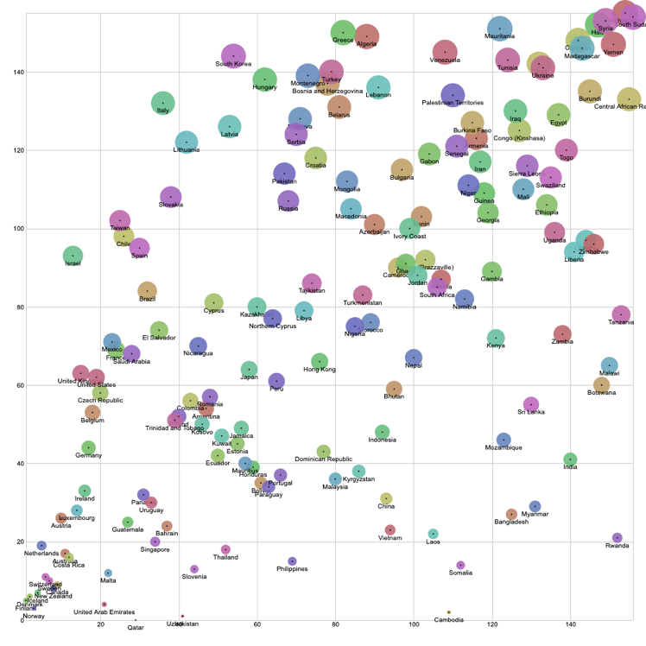

***Figure 3***: Ladder vs. Freedom

The visualization on the left compares a country’s Happiness and Freedom. Countries with happier citizens tend to give their citizens more freedom. A few exceptions include Cambodia and Rwanda. Both rank below 50% in happiness, but 25% or more in freedom. Cambodia ranks second in freedom but 109th in happiness, which is different from the linear correlation seen between the data sets.

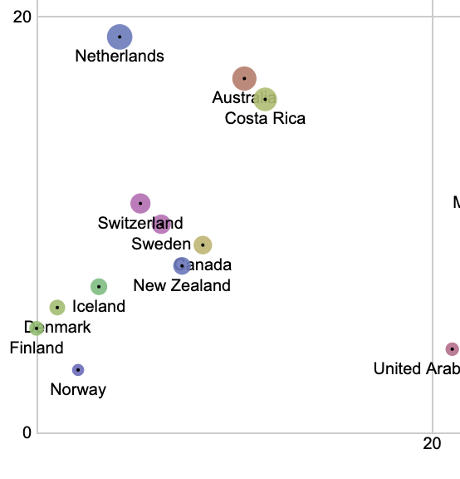The country with the most freedom is Uzbekistan (1/156) ranking 41st in happiness. Uzbekistan ranks higher than many other countries close to it on the ladder in Positive Affect, Social Support, Corruption, and Generosity, but lower in GDP and Health. This could suggest greater freedom due to government corruption. Countries that provide citizens with more freedom directly increase their people’s happiness by doing so. This can be seen in *Figure 4* which is a close up of the lowest grid in *Figure 3*.

**Feedback:** *Chris Sepp*

The representation shows that happier countries give their citizens more freedom. The freest country is Uzbekistan. This plot varies, so a better representation might be one that doesn’t show linear correlation (such as a tree map).